PROJECT ABSTRACT

The project titled “Import Data Using Transform Maps (Spreadsheet)” deals with importing structured information from a spreadsheet into a target application or database. The spreadsheet acts as the source of information, while the target table stores the processed data. The project demonstrates how these two parts can be connected through an import and transformation process.

In a normal manual process, users may enter each record individually into the target system. This approach becomes difficult when hundreds or thousands of records are available. Manual entry also increases the possibility of typing mistakes, missing values, duplicate records, and inconsistent information.

The proposed approach uses an import process to read the spreadsheet data and place it into an intermediate import area. A Transform Map is then used to define the relationship between the imported source fields and the target fields. This makes the data movement more organized and easier to control.

Data validation is an important part of the project. Before the final records are accepted, the imported information can be checked for missing values, incorrect formats, duplicate values, and field mismatches. Errors can be identified and corrected before the data is finally stored.

INTRODUCTION

Data is one of the most important resources used by modern computer applications. Organizations collect information in different formats, including spreadsheets, text files, forms, and databases. When information has to be transferred from one system to another, a proper data import process is required.
A spreadsheet is a simple and commonly used method of storing structured information. It contains rows and columns, where each column represents a particular field and each row represents a record. For example, a student spreadsheet may contain Student ID, Name, Department, Email, and Phone Number.
Although spreadsheets are easy to create, transferring their information manually into another system can be time-consuming. If the number of records is high, manual data entry may lead to incorrect values and repeated work. An automated import process can reduce these problems and improve efficiency.
Transform Maps are useful when source data and target data have different field names or formats. A mapping relationship can be created between the source field and the corresponding target field. Transformation rules can also modify or validate information during the import process.
This project introduces the basic concepts required to perform spreadsheet data import using Transform Maps. It explains each stage from preparing the spreadsheet to verifying the final imported records.

PROJECT BACKGROUND

Many organizations maintain important information in spreadsheet files because spreadsheets are easy to create, edit, and share. Employee information, student details, customer records, product information, and other business data can be maintained in spreadsheet format.

When this information needs to be transferred into a centralized application, manual entry is one possible approach. However, manual entry requires users to enter every record separately. This becomes inefficient when the source file contains a large number of records.

The use of data import techniques provides a better structured approach. Instead of entering every record manually, the spreadsheet can be uploaded and processed by the system. The source information is first read and then prepared for transformation.

A Transform Map provides the mapping between source fields and target fields. For example, a spreadsheet column named “Student Name” can be mapped to a target field named “Name”. This mapping allows the system to understand where each piece of information should be stored.

The background of this project is therefore based on the need for efficient, accurate, and organized data migration. The project demonstrates the importance of automation in handling spreadsheet-based information.
PROBLEM STATEMENT

The main problem addressed by this project is the difficulty of transferring a large amount of spreadsheet information into a target system through manual data entry. Manual entry requires considerable time and continuous human effort.

Another problem is the possibility of data entry errors. Users may enter incorrect names, numbers, dates, email addresses, or other values. Even a small mistake can affect the accuracy of the information stored in the target system.

Duplicate records are another common problem. When the same information is entered more than once, the target system may contain repeated records. Identifying and correcting duplicates manually can require additional effort.

Differences between source and target field names can also create difficulties. For example, the source spreadsheet may contain “Mobile Number”, while the target system may use “Phone”. Without proper mapping, the data may not be stored in the correct field.

Therefore, the project aims to provide a structured method for importing spreadsheet data and mapping it correctly into the target system. The process should reduce manual work, improve consistency, and support better data validation.

PROJECT OBJECTIVES

The primary objective of this project is to understand how spreadsheet data can be imported into a target system using a structured transformation process. The project provides practical knowledge about source data, target data, import operations, and field mapping.

The second objective is to reduce the amount of manual data entry required for transferring records. By importing multiple records together, the system can process information more efficiently than entering each record individually.

Another objective is to correctly map source fields to target fields. Proper field mapping ensures that every value from the spreadsheet is placed in its corresponding location in the target system.

Missing values, incorrect formats, duplicate information, and invalid data can affect the quality of imported records. Validation helps identify such problems before or during the transformation process.

Finally, the project aims to provide an understanding of data transformation and testing. After importing the data, the result must be verified to ensure that the records have been processed correctly and that the expected information is available in the target system.

PROJECT SCOPE

The scope of this project includes the complete process of importing information from a spreadsheet into a target application or database. The project begins with preparing the source spreadsheet and ends with verifying the imported records.

Spreadsheet preparation is included as an important part of the project. The source file should contain properly organized columns and rows. Column headings should be meaningful and the values should follow a consistent format.

The scope also includes creating an import process and defining the relationship between source and target fields. The Transform Map is used to specify how the source information should be transferred into the target structure.

Data validation and error handling are also included in the project. Records can be checked for missing information, invalid values, incorrect formats, and possible duplicate records. Problems identified during the process can be corrected and the import can be performed again.

The project can be applied to different types of structured information such as student records, employee details, customer information, inventory data, and other tabular datasets. The same basic process can be adapted according to the requirements of the target system.

EXISTING SYSTEM

In the existing manual system, information from a spreadsheet is entered into the target application by a user. The user opens the source file, reads each record, and enters the required values into the corresponding fields of the target system.

This method may be suitable when the number of records is very small. For example, entering five or ten records manually may not require much time. However, the same process becomes difficult when the spreadsheet contains hundreds or thousands of records.

Manual data entry also depends heavily on the person performing the task. A user may accidentally enter a wrong value, skip a field, or enter the same record multiple times. These errors can reduce the quality and reliability of the stored data.

Another limitation is that manual processing does not provide a simple reusable mapping process. If the same type of spreadsheet is received regularly, the user may have to repeat the same data entry steps every time.

Therefore, the existing system requires more human effort and may take more time for large datasets. These limitations create the need for an organized import and transformation approach.

LIMITATIONS OF EXISTING SYSTEM

The first limitation of the existing system is the amount of manual work required. Every record must be entered separately, which can take a considerable amount of time when the dataset is large.

The second limitation is the possibility of human errors. Typing mistakes, incorrect selection of values, missing fields, and wrong formats may occur during manual entry. Detecting every error after entry can also require additional effort.

The third limitation is difficulty in maintaining consistency. Different users may enter the same type of information in different formats. For example, dates, names, or phone numbers may be entered differently by different users.

Another limitation is the difficulty of handling repeated imports. If a new spreadsheet has to be imported regularly, manually entering every record again is inefficient. It also increases the possibility of duplicate information.

Because of these limitations, a more systematic method is useful for large-scale data processing. Importing spreadsheet data and using Transform Maps can help organize the process and reduce unnecessary manual operations.

PROPOSED SYSTEM

The proposed system provides a structured method for importing spreadsheet data into a target system. Instead of entering each record manually, the source spreadsheet is uploaded and processed through an import mechanism.

The spreadsheet acts as the source data. The imported information is first made available for processing, after which the Transform Map establishes the relationship between the source fields and the target fields.

During transformation, source values can be transferred into their corresponding target fields. If required, transformation rules can be applied to modify the data before it reaches the target table.

The proposed system also includes validation and error handling. Imported records can be checked for missing values, incorrect formats, duplicate information, and field mapping problems. This helps improve the quality of the final data.

The overall proposed system reduces repetitive manual work and provides a more organized data migration process. It can be used for different structured datasets and can be modified according to the requirements of the target application.

PROPOSED SYSTEM WORKFLOW

The proposed system follows a series of organized steps to transfer information from a spreadsheet into the target system. The process begins with preparing the source spreadsheet and checking whether the data is arranged correctly.

After preparing the spreadsheet, the file is uploaded into the import process. The system reads the spreadsheet and makes the source records available for further processing. This step provides the basic input required for transformation.

The next step is to configure the Transform Map. The Transform Map defines the relationship between the fields in the source data and the fields available in the target table. Correct mapping is important for storing information in the appropriate locations.

After mapping, the transformation process is executed. The system processes the source records and transfers the values to the corresponding target fields. Validation rules may also be applied during this stage.

Finally, the target records are checked to confirm that the import was successful.

ADVANTAGES OF PROPOSED SYSTEM

The proposed system reduces manual data entry by allowing multiple spreadsheet records to be processed together. This saves time when working with large datasets and makes the overall data transfer process more efficient.

Another advantage is improved data consistency. Since the fields are mapped according to predefined relationships, the same type of information can be transferred into the same target fields without requiring the user to enter every value manually.

The proposed system also supports better error identification. Missing values, invalid formats, and mapping problems can be identified during the import and transformation process. This makes it easier to correct problems before the final data is used.

The process can also be repeated whenever new spreadsheet data is available. Once the required configuration is established, similar datasets can be processed using the same basic workflow, depending on the requirements of the target system.

Overall, the proposed system provides a structured approach to spreadsheet data migration. It reduces repetitive work, supports organized field mapping, and provides a better method for processing large amounts of structured information.

FUNCTIONAL REQUIREMENTS

Functional requirements describe the operations that the proposed system should perform. The first requirement is the ability to accept spreadsheet data as the source input. The spreadsheet should contain organized rows and columns with appropriate field names.

The system should provide an import mechanism for reading the source spreadsheet. The imported information should be made available for processing so that each source record can be identified and handled correctly.

The system should support field mapping between the source data and target data. Each important source field should be connected to the appropriate target field through the Transform Map configuration.

The system should support transformation and validation of records. Values may need to be changed, checked, or processed before they are stored in the target table. Invalid or incomplete records should be identifiable for correction.

The final functional requirement is result verification. After the transformation process is completed, the user should be able to check the target records and confirm whether the imported information has been stored correctly.

NON-FUNCTIONAL REQUIREMENTS

Non-functional requirements describe the quality and performance characteristics expected from the project. One important requirement is usability. The import process should be understandable and manageable for a user with basic knowledge of spreadsheet and application operations.

Performance is another important requirement. The system should be able to process the required number of records within a reasonable amount of time. Processing time may depend on the size of the spreadsheet and the capabilities of the target platform.

Data reliability is also required. Information transferred from the spreadsheet should reach the correct target fields without unnecessary changes. The transformation process should maintain the accuracy of the original information wherever possible.

Security is another consideration. Only authorized users should be allowed to perform data import and transformation activities. Sensitive information in the source spreadsheet should also be handled carefully according to the requirements of the organization.

Maintainability is also important. The mapping and transformation configuration should be understandable so that it can be updated when source fields, target fields, or business requirements change.

HARDWARE CONFIGURATION

Hardware configuration refers to the physical resources required to perform the project. A computer or laptop with a modern processor is sufficient for preparing spreadsheets, accessing the target application, configuring the import process, and testing the project.

The system should have sufficient RAM to run the operating system, web browser, spreadsheet application, and other required software smoothly. A minimum of 4 GB RAM can be considered for basic work, while higher memory can provide better performance.

Adequate storage space is required for saving spreadsheet files, project documentation, screenshots, diagrams, and other project-related materials. A computer with sufficient free storage can prevent problems while saving or processing files.

A keyboard and mouse or touchpad are required for entering information, preparing the spreadsheet, configuring the system, and navigating through the application. A display with a suitable resolution is useful for viewing tables and configuration screens.

A stable internet connection may also be required when the target system is web-based. The exact hardware requirements can vary depending on the platform and environment used for implementing the project.
SOFTWARE CONFIGURATION

Software configuration refers to the applications and tools required for developing and testing the project. An operating system such as Windows, Linux, or another supported platform can be used depending on the environment.

A spreadsheet application is required for preparing the source data. Microsoft Excel or another compatible spreadsheet application can be used to create rows, columns, field names, and records in the required format.

A modern web browser may be required when the target application is accessed through the web. Browsers such as Chrome, Edge, or Firefox can be used depending on the compatibility requirements of the target platform.

The target application or data management platform is required for creating the import process and Transform Map. The exact platform depends on the environment selected for the project. If a platform provides import sets and Transform Maps, those features can be used for implementation.

Microsoft Word or another document editor can be used for preparing the project documentation. Screenshot tools can also be used to capture important stages of the import and transformation process.

SYSTEM ARCHITECTURE

System architecture describes the major components involved in the spreadsheet data import process. The first component is the source data layer, which contains the spreadsheet prepared by the user.

The second component is the import layer. The spreadsheet is uploaded or provided as input to the import mechanism. The system reads the rows and columns and prepares the information for transformation.

The third component is the Transform Map layer. This component defines the relationship between the source fields and the target fields. It acts as an important connection between the imported information and the final target structure.

The fourth component is the target data layer. After transformation, the processed values are stored in the required target table or application records. The target data should contain the information in the correct structure.

The final component is the validation and verification layer. The imported records are checked to determine whether the process produced the expected result. Errors can be identified and corrected before the final data is considered complete.

SOURCE DATA LAYER

The source data layer contains the original information that needs to be imported into the target system. In this project, the source information is maintained in a spreadsheet format containing rows and columns.

Each column in the spreadsheet represents a particular field. For example, a spreadsheet may contain fields such as ID, Name, Email, Department, Phone Number, or Address depending on the type of data being processed.

Each row represents one complete record. The values in the row should follow the expected format of the corresponding column. Proper organization of rows and columns is important for successful data import.

Before uploading the spreadsheet, the user should check the data for empty headings, unnecessary columns, incorrect formats, duplicate records, and other problems. Cleaning the source data can reduce errors during transformation.

The source data layer therefore acts as the starting point of the complete workflow. The quality of the source spreadsheet directly affects the quality of the information that is finally stored in the target system.

IMPORT SET LAYER

The import set layer acts as an intermediate area between the source spreadsheet and the target table. It allows the imported source information to be received and processed before the final transformation takes place.

When the spreadsheet is imported, its records are made available in the import area. The system can use this information as the source for the Transform Map. This separates the original source data from the final target records.

The import set structure helps the user examine the imported information before transforming it. Field names and values can be reviewed to determine whether the spreadsheet has been read correctly.

The import set can also help identify problems in the source data. If a column is missing, a value is incorrectly formatted, or the spreadsheet structure is not as expected, the problem can be identified during the import stage.

Therefore, the import set layer provides an important intermediate step in the overall architecture. It supports organized processing and helps connect the source spreadsheet with the transformation stage.

TRANSFORM MAP LAYER

The Transform Map layer is one of the most important components of the project. It defines how the source data should be transferred into the target table. The map establishes relationships between source fields and target fields.

For example, if the source spreadsheet contains a column called “Student Name” and the target table contains a field called “Name”, the Transform Map can establish the connection between these two fields.

Multiple source fields can be mapped to their corresponding target fields. The mapping should be checked carefully because an incorrect mapping may place information in the wrong location.

Transformation logic can also be applied when required. A value may need to be modified, formatted, combined, or validated before it is stored in the target field. Such processing depends on the requirements of the project.

The Transform Map therefore acts as the main bridge between imported source information and final target records. Correct configuration of this layer is essential for achieving accurate and reliable data migration.

TARGET DATA LAYER

The target data layer is the final destination of the information imported from the spreadsheet. After the source records are processed and transformed, the resulting values are stored in the required target table or application.

The target table contains fields that are designed to store specific types of information. Each field may have a particular name, format, and purpose. The source data must therefore be mapped correctly to these target fields.

VALIDATION LAYER
Validation is the process of checking whether the imported information satisfies the required conditions. It is an important part of the project because incorrect data should be identified before it causes problems in the target system.
One basic validation is checking for missing values. Required fields should contain appropriate information. If an important field is empty, the record may need to be corrected before it is accepted.
Format validation is another important check. Values such as email addresses, phone numbers, dates, and identification numbers may need to follow specific formats. Incorrect formats can create inconsistent records.
Duplicate checking can also be performed during validation. If the same record appears more than once, the duplicate should be identified and handled according to the requirem.
DATA FLOW

The data flow begins with the source spreadsheet. The user prepares the spreadsheet with the required headings and records. The file acts as the initial input for the complete data import process.

The prepared spreadsheet is then uploaded through the import mechanism. The system reads the information contained in the rows and columns and makes the records available in the intermediate import area.

The imported information is then connected to the target structure through the Transform Map. Source fields are matched with the corresponding target fields according to the configured mapping.

During transformation, the system processes the records and transfers the required values into the target table. Transformation rules may be used when the source information needs to be changed or validated.

Finally, the target records are reviewed. The user verifies whether the expected values have been transferred correctly and identifies any errors that require correction.

SYSTEM COMPONENTS

The first major component of the project is the spreadsheet source. It contains the original records that need to be transferred into the target system. The spreadsheet should be properly structured before the import begins.

The second component is the import mechanism. It receives the spreadsheet and processes the source information. This component allows the records to become available for further transformation.

The third component is the Transform Map. It connects the source fields with the target fields and controls how the imported values should be transferred. This is an important part of the data migration process.

The fourth component is the target table or application. It receives the processed information after transformation. The target structure must contain the required fields for storing the imported records.

The final component is validation and verification. It checks the output and helps identify problems such as missing values, incorrect mapping, duplicate records, or unexpected results.

USE CASE DIAGRAM

A Use Case Diagram represents the interaction between a user and the major functions of the proposed system. In this project, the main actor is the user who performs the spreadsheet import and transformation activities.

The user first prepares the spreadsheet containing the required information. This activity is important because the quality and structure of the source file can affect the success of the import process.

The user then uploads the spreadsheet and configures the required import settings. After the data is available, the user creates or selects the appropriate Transform Map for connecting source fields with target fields.

The transformation process is then executed by the user. The system processes the imported records according to the configured mapping and stores the resulting information in the target table.
After transformation, the user verifies the target records. The main use cases can therefore be represented as Prepare Data, Upload Data, Configure Mapping, Transform Data, Validate Data, and Verify Results.
Diagram representation to draw in Word:
Actor → Prepare Spreadsheet → Upload Data → Configure Transform Map → Run Transform → Validate Records → Verify Target Data.
USE CASE – PREPARE DATA

The Prepare Data use case describes the first activity performed before the import process begins. The user creates or receives a spreadsheet containing the information that needs to be transferred.

The spreadsheet should have meaningful column headings. Each heading should represent a field that can be understood by the user and can be related to a field in the target table.

The user should also check the values in each row. Empty fields, incorrect values, unnecessary spaces, duplicate records, and inconsistent formats should be reviewed before the file is uploaded.

The spreadsheet should be saved in a format supported by the import process. The user should also ensure that the file is available at the location from which it will be uploaded.

Proper preparation of the source data reduces problems in later stages. A clean and well-organized spreadsheet provides a better starting point for field mapping and transformation.

USE CASE – UPLOAD DATA

The Upload Data use case describes the process of providing the prepared spreadsheet to the import system. The user selects the appropriate spreadsheet file and starts the import operation.

Before uploading, the user should confirm that the correct file has been selected. The file should contain the latest version of the required records and should follow the expected spreadsheet structure.

During the upload process, the system reads the spreadsheet and prepares the records for further processing. The information is made available through the import mechanism or intermediate import area.

After uploading, the user should review the imported information. This helps confirm that the spreadsheet was read correctly and that the expected columns and records are available.

Successful uploading provides the source information required for the next stage. If the file cannot be processed, the user should check the file format, column structure, and other import requirements before trying again.

USE CASE – CONFIGURE TRANSFORM MAP

The Configure Transform Map use case describes the process of creating the mapping relationship between the imported source data and the target table. The user selects the appropriate source and target structures.

The user identifies each source field that needs to be transferred. For every required source field, a corresponding target field should be selected based on the meaning and format of the information.

The mapping must be checked carefully. For example, a source field containing an email address should be connected to the appropriate email field rather than a name or phone field.

If transformation logic is required, the user can configure the appropriate rules according to the requirements of the project. These rules may process or modify source values before they are stored.

After configuration, the Transform Map should be reviewed before running the transformation. Correct configuration helps ensure that the imported records are stored in the expected target fields.

USE CASE – MAP FIELDS

Field mapping is the process of connecting each source field to the correct target field. It is one of the most important steps because incorrect mapping can result in incorrect target records.

The source spreadsheet may use different field names from the target system. For example, the spreadsheet may use “Phone Number” while the target table may use “Contact Number”. The user must identify that both fields represent the same type of information.

The mapping should consider the data type as well as the meaning of the field. Text information should be mapped to suitable text fields, numbers to appropriate numeric fields, and dates to suitable date fields.

All required fields should be reviewed before the transformation is executed. Unmapped required fields may result in incomplete records or errors during processing.

After the mapping is completed, the user should verify the configuration. A properly mapped set of fields provides a strong foundation for successful data transformation.

USE CASE – RUN TRANSFORMATION

The Run Transformation use case represents the stage where the imported source records are processed according to the configured Transform Map. The user starts the transformation after checking the source data and field mapping.

During transformation, the system reads the imported records and applies the configured field relationships. Each source value is transferred to the appropriate target field according to the mapping.

If transformation rules are configured, the system can apply those rules during processing. This may include checking values, modifying formats, or applying other project-specific data processing requirements.

After the transformation is completed, the user should review the processing result. The system may provide information about successful records, records requiring attention, or errors encountered during processing.

The final step is to verify the target data. The user checks whether the expected records and values are available in the target table and confirms that the transformation produced the required result.

VALIDATE IMPORTED DATA

Validation of imported data is an important step after the transformation process. It helps determine whether the information received from the spreadsheet has been transferred correctly into the target system.

The first validation is to compare the number of source records with the number of target records. This provides a basic indication of whether all expected records have been processed.

The values of important fields should also be compared. Names, identification numbers, email addresses, departments, dates, and other relevant values should match the original spreadsheet wherever no transformation was intentionally applied.

Missing values should be identified during validation. If a required field is empty in the target record, the source data and mapping configuration should be checked to determine the reason.

Validation provides confidence in the final data. Any errors identified during this stage can be corrected and the transformation process can be performed again when necessary.

FLOWCHART

A flowchart is a graphical representation of the sequence of activities performed by the system. In this project, the flowchart explains how spreadsheet data moves from the source file to the final target table.

The process starts with preparing the spreadsheet. The user checks the column headings and records before providing the file to the import system.

The next step is uploading the spreadsheet. After successful upload, the imported records are examined and the required Transform Map is configured.

The transformation is then executed. The system processes the source records according to the field mapping and any applicable transformation rules.

The final stage is validation and verification. If errors are identified, the user corrects the source data or configuration and repeats the required steps. If the result is correct, the process is completed.
Flowchart to draw:
Start → Prepare Spreadsheet → Upload File → Import Data → Configure Transform Map → Map Fields → Run Transform → Validate Data → Correct Errors if Required → Verify Target Records → End.

UML DIAGRAM

Unified Modeling Language, commonly called UML, is used to represent the structure and behavior of a software system. UML diagrams make it easier to understand how different components and users interact with the system.

For this project, the UML representation can describe the relationship between the user, spreadsheet data, import process, Transform Map, and target table. Each component has a specific role in the overall data migration workflow.

The user interacts with the system by preparing the spreadsheet, uploading the file, configuring the mapping, starting the transformation, and checking the results. These activities represent the major operations performed by the user.

The import process receives the spreadsheet information and makes it available for transformation. The Transform Map connects the source fields with the appropriate target fields and controls the movement of data.

The target table stores the processed records. The UML representation therefore provides a simplified view of the complete workflow and helps explain how the major parts of the system are connected.
UML representation:
User → Spreadsheet → Import Process → Transform Map → Target Table → Validation.
DATA MODEL

A data model describes how information is organized within the project. In the spreadsheet import process, the source data consists of records arranged in rows and fields arranged in columns.

Each source record contains values related to a particular item or person. For example, a record may contain an ID, name, email address, department, and phone number.

The target data model contains corresponding fields where the processed values are stored. The source and target structures do not always need to have exactly the same field names, but their meanings should be understood during mapping.

Relationships between source fields and target fields are established through the Transform Map. This relationship ensures that each value reaches the correct destination.

A well-defined data model helps prevent confusion during the import process. It also makes the system easier to understand, test, maintain, and modify when requirements change.

FIELD MAPPING

Field mapping defines how information from the spreadsheet is connected to fields in the target table. Every source column that needs to be transferred should have a suitable target field.

For example, a source column named “Student ID” can be mapped to a target field called “ID”. Similarly, “Student Name” can be mapped to “Name”, and “Email Address” can be mapped to an email field.

Field mapping should be based on the meaning and data type of the information. Mapping a field to an incorrect target field can result in inaccurate records.

The mapping configuration should be reviewed before the transformation begins. Required fields should not be left without a proper mapping unless the target system provides another method for generating their values.

Correct field mapping improves the reliability of the transformation process. It also makes the import configuration easier to understand and maintain.
Example mapping:
Student ID → ID
Student Name → Name
Email Address → Email
Department → Department
Phone Number → Phone.
SPREADSHEET PREPARATION

Preparing the spreadsheet correctly is the first practical step in the data import process. A well-structured spreadsheet helps the system understand the source information and reduces errors during import.

The first row should normally contain meaningful column headings. These headings identify the type of information stored in each column and help the user create the appropriate field mapping.

The records should be entered consistently. For example, if a column is used for phone numbers, all values should follow a suitable format. Dates and other structured values should also be maintained consistently.

Unnecessary blank rows and columns should be removed where appropriate. Duplicate records should also be reviewed because they may create duplicate information in the target system.

After checking the data, the spreadsheet should be saved in a supported file format. The final file should be reviewed once again before it is uploaded to the import system.

IMPORT FILE FORMAT

The import file contains the source information that will be transferred to the target system. A spreadsheet format is useful because information can be organized clearly using rows and columns.

The first row generally contains the field names. These names should clearly describe the information contained in each column and should be easy to relate to the target fields.

Each following row represents a separate record. The values in a row should belong to the corresponding columns. This structure allows the import mechanism to process each record systematically.

The file should be saved in a format supported by the target platform. The user should also ensure that special characters, dates, numbers, and other values are stored in an appropriate format.

Before starting the import, the user should verify the file name, file format, number of records, and column structure. Proper file preparation can prevent many common import problems.

IMPORT SET CONFIGURATION

Import set configuration involves preparing the system to receive information from the source spreadsheet. The configuration provides the connection between the uploaded source data and the later transformation process.

The user selects the appropriate source file and provides the required import information. The system then reads the spreadsheet and prepares the records for processing.

The imported data should be reviewed after the import operation. The user can check whether the expected columns and records are available and whether any problems occurred during the import.

The import configuration should be related to the appropriate target structure. This helps ensure that the later Transform Map can use the imported source information correctly.

Proper import set configuration creates a reliable intermediate stage between the spreadsheet and the target table. It helps organize the source records before they are transformed.

TRANSFORM MAP CONFIGURATION

Transform Map configuration involves defining the source and target structures used during transformation. The user selects the appropriate imported source data and the target table where the final records should be stored.

After selecting the source and target, the required fields are mapped. The user checks the source column names and connects them with the appropriate target fields.

The configuration may also include options that control how records are processed. Depending on the target platform, the user may configure matching fields, transformation rules, or other processing options.

The Transform Map should be reviewed carefully before it is executed. Incorrect source or target selection can cause records to be transferred incorrectly.

A properly configured Transform Map provides the main connection between imported spreadsheet information and the target records. It is therefore an important configuration step in the project.

TRANSFORMATION RULES

Transformation rules define how source information should be processed before it is stored in the target system. They are useful when the source data requires modification, validation, or special handling.

A simple transformation may involve changing the format of a value. For example, a date stored in one format may need to be represented in another format required by the target field.

Transformation rules can also be used to check values. If a required field is empty or contains an invalid value, the record can be identified for further review according to the capabilities of the target system.

Another possible use is combining or processing information from multiple source fields. The exact transformation depends on the requirements of the project and the features supported by the target platform.

Transformation rules should be tested carefully before using them with important data. Correctly designed rules help maintain data quality while ensuring that the source information reaches the target system in the required form.

DATA VALIDATION

Data validation is the process of checking whether the information being imported follows the required conditions. It helps ensure that the final records are accurate, complete, and suitable for use.

One important validation is checking required fields. Fields that are necessary for identifying or processing a record should contain valid information. Empty required fields may cause incomplete target records.

Data type and format validation should also be performed. Numbers, dates, email addresses, and other structured values should follow the expected format. Incorrect values should be identified before they affect the target data.

Duplicate checking is another important validation activity. The source spreadsheet should be reviewed for repeated records, and the target system should also be checked after transformation when duplicate prevention is required.

Proper validation improves the quality of the final data. It helps identify problems early and provides an opportunity to correct the source information or mapping configuration.

ERROR HANDLING

Error handling refers to identifying and managing problems that occur during the import and transformation process. Errors can occur because of incorrect files, missing values, invalid formats, or incorrect field mapping.

One common error is an incorrect spreadsheet structure. If the required column headings are missing or changed, the import process may not work as expected. The spreadsheet should be corrected and uploaded again.

Another possible error is invalid data. For example, a field that requires a number may contain text. Such records should be identified and corrected before the transformation is completed.

Mapping errors can also occur when a source field is connected to the wrong target field. The Transform Map should be reviewed carefully whenever unexpected values appear in the target records.

A proper error-handling process improves reliability. The user should identify the cause of the error, correct the source data or configuration, and repeat the required step while keeping track of the changes made.

DUPLICATE HANDLING

Duplicate records occur when the same information appears more than once in the source data or when the same record is imported repeatedly. Duplicate handling is therefore an important part of data quality management.

The source spreadsheet should be checked before importing the data. If the same record appears multiple times, the duplicate entries should be reviewed and unnecessary records can be removed where appropriate.

The target system should also be considered when importing records. A suitable field or combination of fields may be used to identify existing records depending on the design of the target application.

Correct field mapping and matching rules can help prevent unwanted duplicate records. The exact method depends on the features available in the platform used for the project.

After transformation, the target records should be reviewed for unexpected duplicates. Proper duplicate handling helps maintain a clean dataset and prevents confusion when the information is used later.

IMPORT EXECUTION

Import execution is the stage where the prepared spreadsheet is processed by the system. Before starting the operation, the user should confirm that the source file and configuration are correct.

The spreadsheet is provided to the import mechanism and the system reads the available records. The imported information is then made available for transformation through the configured process.

After the source data is ready, the Transform Map is used to connect the source records with the target table. The system processes each record according to the configured field mappings and transformation rules.

The execution result should be reviewed after the process is completed. The user should check whether the expected records were processed and whether any records require attention.

Import execution should be performed carefully, especially when dealing with important or large datasets. Reviewing the configuration before execution can reduce avoidable errors.

RESULT VERIFICATION

Result verification is the final checking stage after the transformation has been completed. Its purpose is to confirm that the imported information has reached the target system correctly.

The user should compare selected source records with the corresponding target records. Important values should be checked to make sure that they have been transferred to the correct fields.

The number of records can also be compared where appropriate. If the source contains a known number of valid records, the target result can be checked to identify missing or unexpected records.

Any errors found during verification should be investigated. The cause may be related to the source spreadsheet, field mapping, transformation rules, or other configuration settings.

Successful verification provides evidence that the import process produced the expected result. The final records can then be used according to the purpose of the target application.

ALPHA TESTING

Alpha testing is performed during the development or internal testing stage of a project. It is generally carried out in a controlled environment before the system is provided for wider use.

For this project, alpha testing can be used to check the basic spreadsheet import process. The tester can verify whether the file is accepted and whether the imported records are available for transformation.

Field mapping can also be tested during alpha testing. The tester checks whether source fields are connected to the correct target fields and whether the resulting values appear in the expected locations.

Validation and error-handling functions can also be examined. Test data containing missing values, incorrect formats, and duplicate records can be used to observe how the system handles such conditions.

The purpose of alpha testing is to identify problems at an early stage. Any issues found should be corrected before the project is used in a broader testing or production environment.

BETA TESTING

Beta testing is performed after the basic functionality has been developed and internally tested. It provides an opportunity to evaluate the system using realistic data and usage conditions.

For this project, beta testing can involve using a representative spreadsheet containing realistic records. The complete workflow from upload to transformation and verification can be tested.

Users can observe whether the import process is understandable and whether the resulting records satisfy the expected requirements. Any usability problems can also be identified during this stage.

Different types of input data can be tested, including valid records, incomplete records, duplicate values, and different formats. This helps determine whether the system behaves appropriately under different conditions.

The findings from beta testing can be used to improve the project before final submission or deployment. The exact test results should be recorded based on the tests actually performed.

TESTING STRATEGY

Testing is performed to determine whether the spreadsheet import and transformation process works according to the expected requirements. A systematic testing strategy helps identify problems before the final result is accepted.

The first testing stage is input testing. The source spreadsheet is checked to determine whether valid and invalid records are handled appropriately by the import process.

The second stage is mapping testing. Each important source field is checked against its corresponding target field. This ensures that the Transform Map transfers values to the correct locations.

The third stage is transformation testing. The configured transformation rules are tested to determine whether values are processed as expected and whether errors are handled correctly.

The final stage is output testing. The target records are reviewed and compared with the expected results. Test observations should be documented clearly so that problems can be corrected and retested.

TEST CASES

Test cases provide a structured way to check different parts of the project. Each test case should contain a test condition, expected result, and actual result based on the test performed.

Test Case 1 – Valid Spreadsheet: A correctly formatted spreadsheet is imported. The expected result is that the records are accepted and made available for transformation.

Test Case 2 – Field Mapping: Source fields are mapped to the corresponding target fields. The expected result is that each value appears in the correct target field after transformation.

Test Case 3 – Missing Value: A record contains an empty required field. The expected result is that the problem is identified according to the validation rules configured in the system.

Test Case 4 – Duplicate Record: The source contains repeated information. The expected result is that the duplicate can be identified and handled according to the project requirements.

Test Case 5 – Invalid Format: A value does not follow the expected format. The expected result is that the invalid value is identified or handled according to the configured validation and transformation process.

TEST RESULTS

Test results document what happened when the project functions were tested. The results should be recorded based on the actual execution of each test case rather than assumed results.

For valid spreadsheet data, the expected result is successful import and availability of records for transformation. The tester should record whether this result was actually observed during testing.

For field mapping tests, the source and target values should be compared. If the values appear in the correct target fields, the mapping can be considered to have produced the expected result for that test data.

For invalid or incomplete records, the tester should record how the system responded. The result may include an error message, skipped record, validation issue, or another response depending on the platform configuration.

The complete test record should include the test case number, test description, expected result, actual result, and status. Any failed test should be investigated, corrected, and tested again before final submission.

SECURITY

Security is an important consideration when importing information from a spreadsheet into a target system. The source file may contain information that should only be accessed by authorized users.

Only users with the required permissions should be allowed to upload files, configure mappings, and perform transformation activities. Access control helps prevent unauthorized changes to important records.

The spreadsheet should be stored safely before and after the import process. If the file contains sensitive information, it should not be shared with unauthorized persons.

User credentials should also be protected. Users should avoid sharing passwords and should log out from the application when using a shared computer.

Following basic security practices helps protect both the source spreadsheet and the target data. Security requirements may vary depending on the orgaization and platform used for implementation.

DATA INTEGRITY

Data integrity means maintaining the accuracy, consistency, and reliability of information throughout the import process. The data should not be changed incorrectly while moving from the spreadsheet to the target system.

The first step toward maintaining data integrity is preparing accurate source data. Incorrect information in the spreadsheet can result in incorrect target records even when the import configuration is correct.

Field mapping is also important for data integrity. Every source field should be connected to the correct target field so that values are stored in their intended locations.

Transformation rules should be designed carefully. Any changes applied during transformation should be intentional and should follow the requirements of the project.

Verification after transformation provides an additional check on data integrity. Comparing selected source and target records can help identify unexpected changes or missing information.

PERFORMANCE

Performance refers to how efficiently the system can process the spreadsheet data. The time required for importing and transforming records may depend on the number of records and the configuration of the target system.

For a small spreadsheet, the import process may complete quickly. As the number of records increases, the processing time may also increase depending on system resources and platform limitations.

The source spreadsheet should therefore be prepared efficiently. Unnecessary columns, empty rows, and duplicate records should be removed where appropriate before starting the import.

The transformation configuration should also be kept organized. Unnecessary processing rules may increase complexity and can make troubleshooting more difficult.

Performance should be evaluated using realistic project data. The actual processing time and results should be recorded during testing rather than assumed in advance.

TROUBLESHOOTING

Troubleshooting is the process of identifying and correcting problems that occur during the spreadsheet import and transformation process. A systematic approach can help find the cause of an issue.

If the spreadsheet cannot be imported, the file format and structure should be checked first. The user should verify that the file is supported and that the required headings and records are available.

If values appear in the wrong target fields, the field mapping should be reviewed. The source field and target field should be compared to make sure the mapping relationship is correct.

If records are missing, the user should check the source data, validation conditions, transformation rules, and import results. The reason for the missing record should be identified before repeating the process.

Troubleshooting becomes easier when each stage is checked separately. The source file, import stage, Transform Map, transformation process, and target records should be examined systematically.

MAINTENANCE

Maintenance involves keeping the project configuration and documentation updated after the initial implementation. Changes may be required when the spreadsheet structure or target system requirements change.

If a new source column is added, the Transform Map may need to be updated. The new field should be reviewed and connected to the appropriate target field when required.

Changes in target fields may also require modifications to the mapping configuration. The user should verify existing mappings whenever the target structure is changed.

The source spreadsheet format should be monitored regularly. Changes in column names, data types, or record formats can affect the import process and should be considered before importing new files.

Proper maintenance helps keep the data import process reliable over time. Documentation should also be updated whenever important configuration changes are made.

RISKS AND MITIGATION

A project may face different risks during spreadsheet data import. One common risk is incorrect source data. If the spreadsheet contains wrong or incomplete information, the target records may also become inaccurate.

Another risk is incorrect field mapping. A source field mapped to the wrong target field can cause information to be stored incorrectly. Reviewing and testing the mapping can reduce this risk.

Duplicate records are another possible risk. Repeated imports or duplicate source rows may create repeated target records. Checking the source data and using appropriate matching methods can help manage this problem.

Data security is also a consideration. Unauthorized access to the spreadsheet or target system may expose information. Access control and safe file handling can reduce this risk.

Regular testing, validation, backup procedures, and careful configuration can help reduce project risks. Any identified risk should be documented and handled according to the project requirements.

FUTURE ENHANCEMENTS

The project can be improved in several ways in the future. One possible enhancement is to provide more automated validation of spreadsheet records before the import begins.

Another enhancement could be automatic identification of duplicate records. This can help reduce repeated information and improve the quality of the target dataset.

The system could also be extended to support additional source formats. Instead of depending only on spreadsheets, future versions could support other structured data formats when required by the target platform.

More detailed error reporting can also be introduced. A report could identify the record, field, and reason for an error so that the user can correct the problem more easily.

Future improvements may also include better monitoring, automated notifications, improved security controls, and reusable transformation configurations. These enhancements can make the data import process more efficient and easier to manage.

SCREENSHOT DOCUMENTATION

Screenshots are useful for showing the practical implementation of the project. They provide visual evidence of the important steps performed during spreadsheet import and transformation.

The first screenshot can show the prepared spreadsheet containing the source records. The screenshot should clearly display the column headings and sample data used for the project.

The second screenshot can show the import process or import set configuration. This demonstrates that the spreadsheet has been provided to the target system and that the source information is available for processing.

The third screenshot can show the Transform Map configuration and field mappings. This screenshot should clearly show the relationship between the source fields and target fields.

Additional screenshots can show the transformation execution, validation results, and final target records. Each screenshot should have a suitable caption explaining what is displayed.
Important: Actual screenshots from your project should be inserted in this section. Do not use sample screenshots if your faculty requires proof of your own implementation.

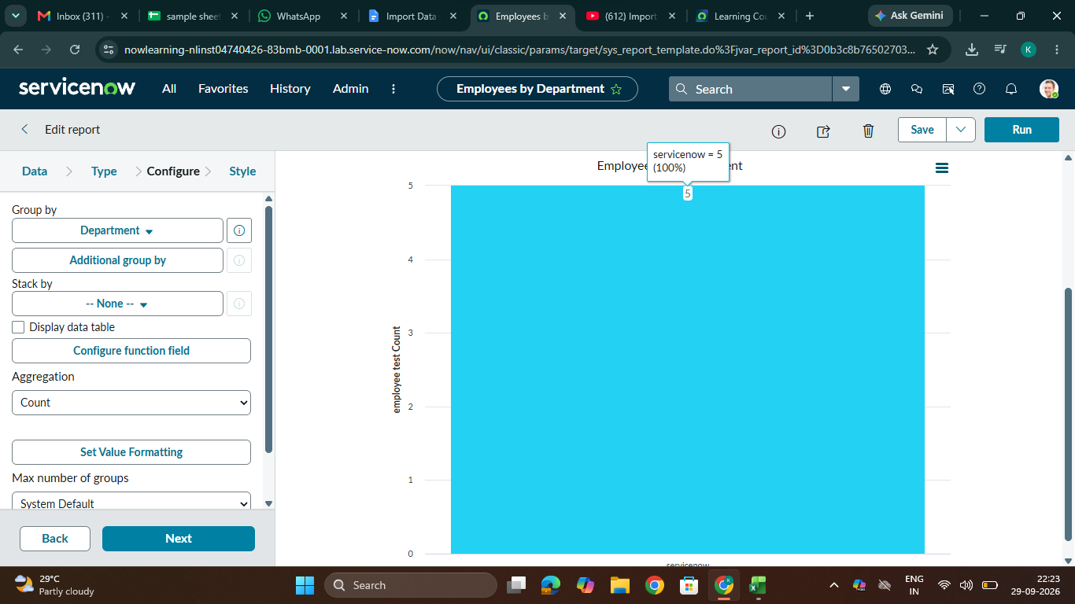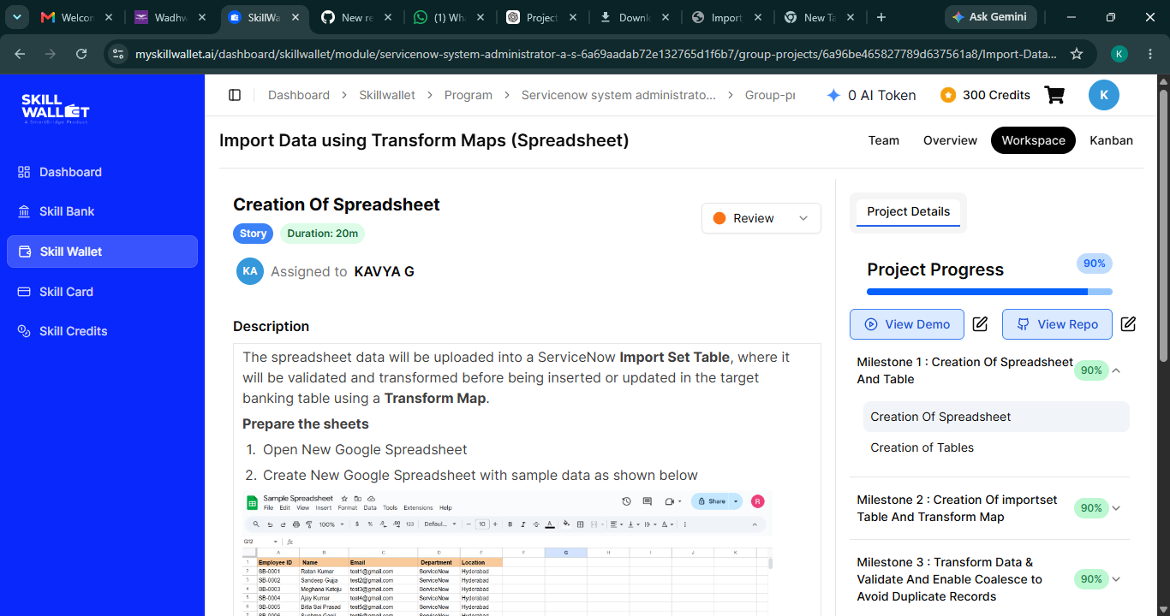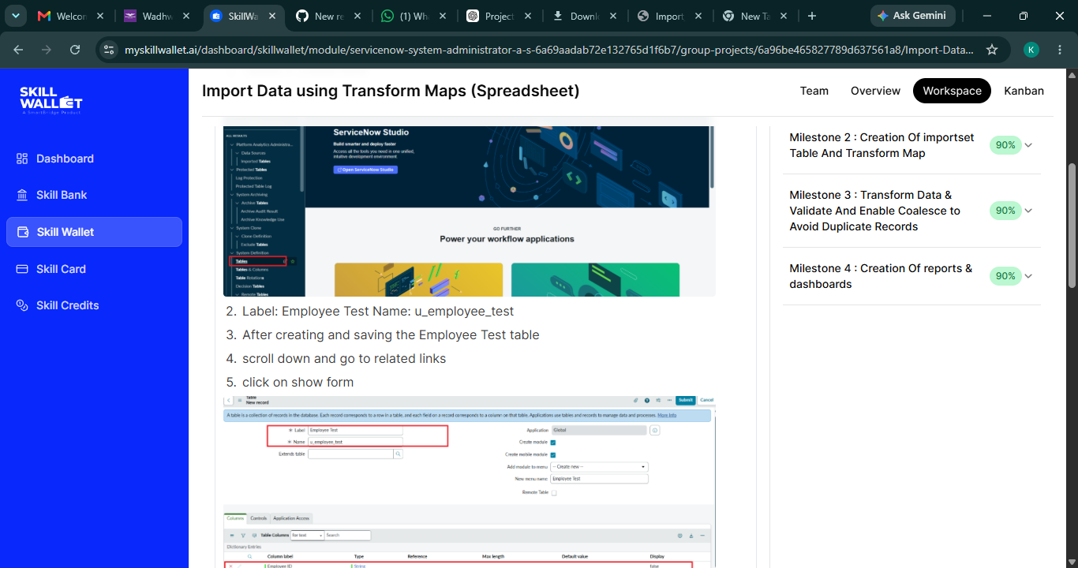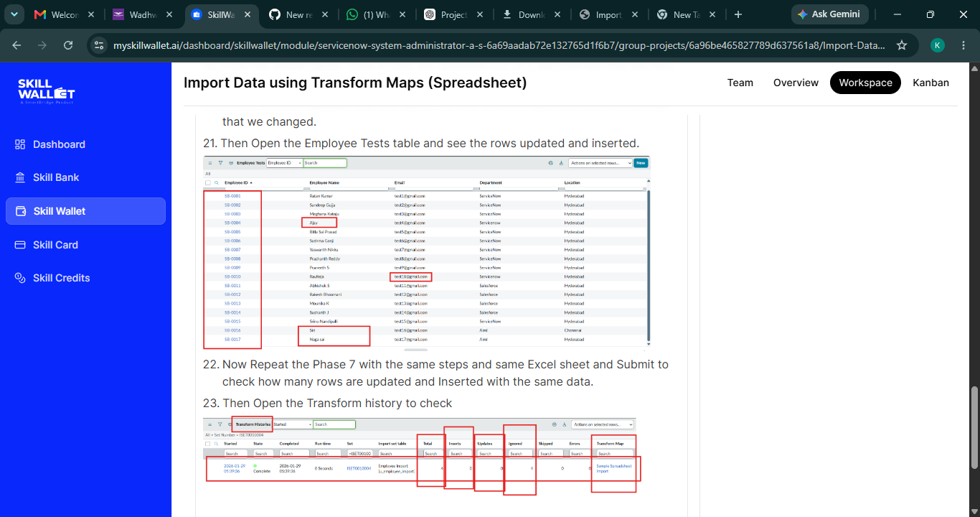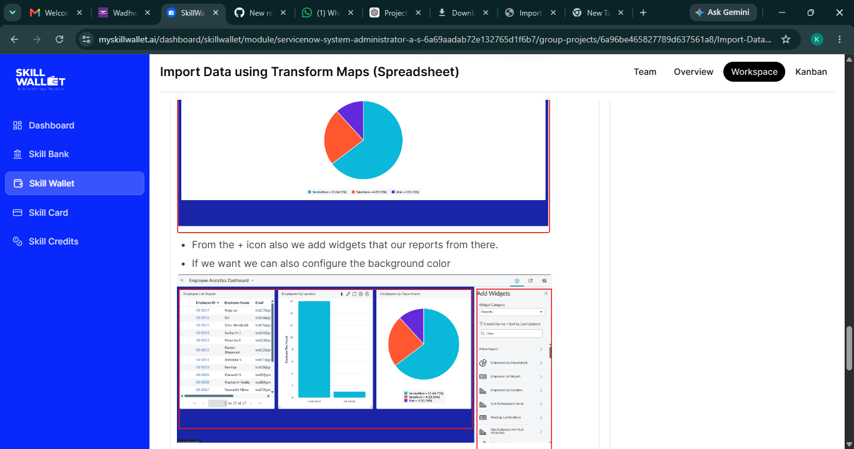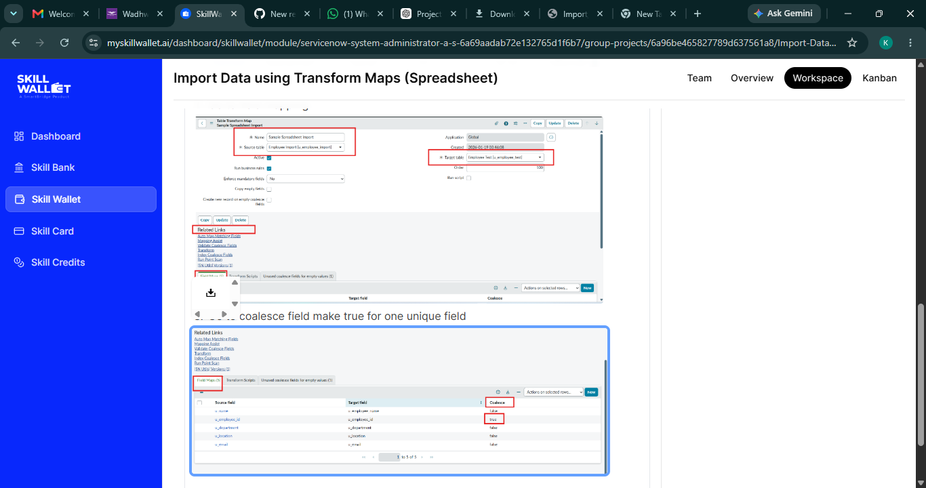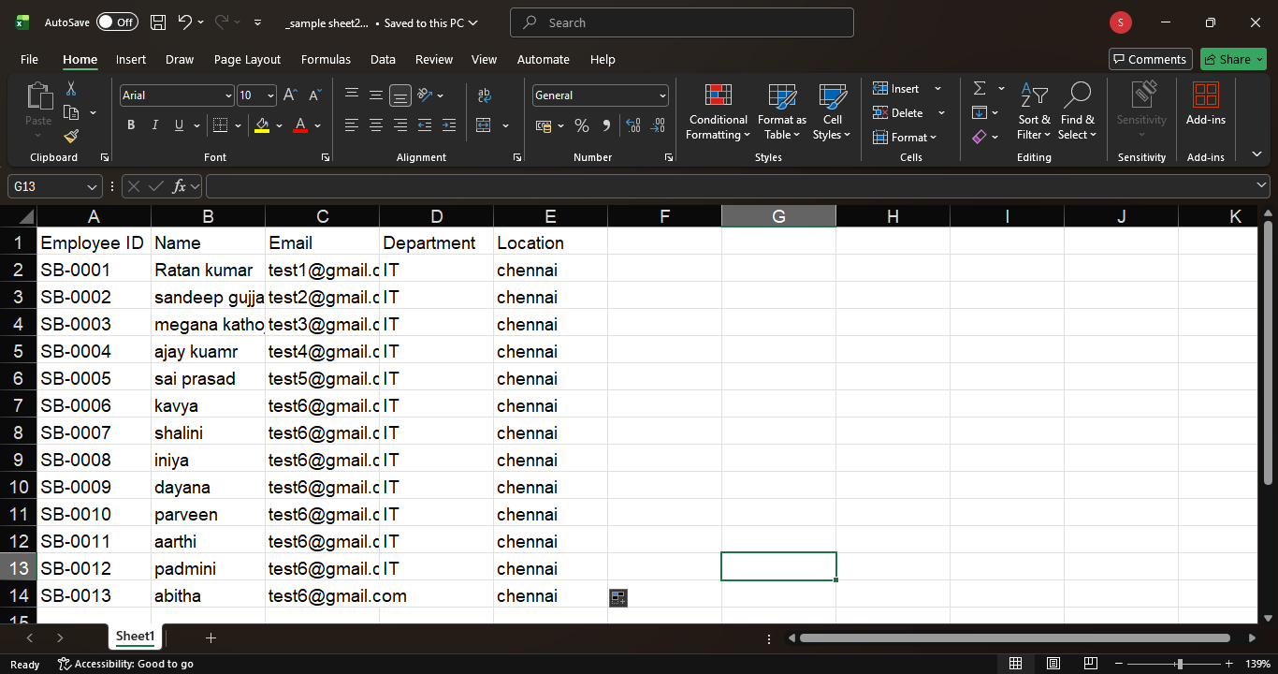

CONCLUSION

The project “Import Data Using Transform Maps (Spreadsheet)” provides an understanding of how structured information can be transferred from a spreadsheet into a target system. The project demonstrates the importance of organized data processing.

The process begins with preparing the spreadsheet and checking the source information. The data is then imported and made available for transformation through the appropriate import mechanism.

Transform Maps provide the connection between source fields and target fields. Correct mapping ensures that the values from the spreadsheet are transferred to the appropriate locations in the target system.

Validation and testing are also important parts of the project. They help identify missing values, incorrect formats, duplicate records, mapping errors, and other issues that may affect the final result.

Overall, the project provides practical knowledge about spreadsheet-based data migration, field mapping, transformation, validation, testing, and verification. It also demonstrates how a structured import process can reduce repetitive manual data entry and improve data management.

REFERENCES AND APPENDIX

This project documentation is based on general concepts related to spreadsheet data import, data transformation, field mapping, validation, database concepts, and software testing. The references used for the project should be listed according to the actual resources consulted during implementation.

Useful reference materials may include the official documentation of the platform used for the project, spreadsheet application documentation, classroom notes, laboratory instructions, and approved learning resources provided by the institution.

The appendix can contain additional information that supports the project. This may include sample spreadsheet structures, field-mapping tables, test case tables, flowchart details, UML representations, and other supporting material.
The appendix may also include screenshots that were not included in the main documentation. Each screenshot should have a clear caption and should represent an actual stage of the project implementation whenever screenshots are required as project evidence.

Final project checklist: Project Abstract, Proposed System, Existing System, Hardware Configuration, Software Configuration, Use Case Diagram, Flowchart, UML Diagram, Alpha Testing, Beta Testing, Screenshots, Conclusion, and References. With these sections completed, the manual documentation covers the major requirements of the project.

